When installing Accutrack on a Windows 7 (or Windows 10) machine, you may run into problems that require a couple of adjustments. The problems result from the fact that Accutrack uses Excel to do its calculations and produce its reports. The first issue is that you must be using a full copy of Microsoft Office. The starter copy that is shipping with a lot of laptops will not work. Secondly, you need to turn off the UAC and you may also need to change some compatibility settings. Once you get to the Control Panel in Windows 8, or 10, the process is the same. You can access the control panel from Charms\Settings or from Windows Key-X. For using Accutrack with Windows 10, it is very important to take all 3 steps of turning off the UAC, setting compatibility and defining the user as an administrator on the machine.
How to Turn Off UAC in Windows 7
- Go to Start\Control Panel\Action Center. You will see the following screen. Click on Security .

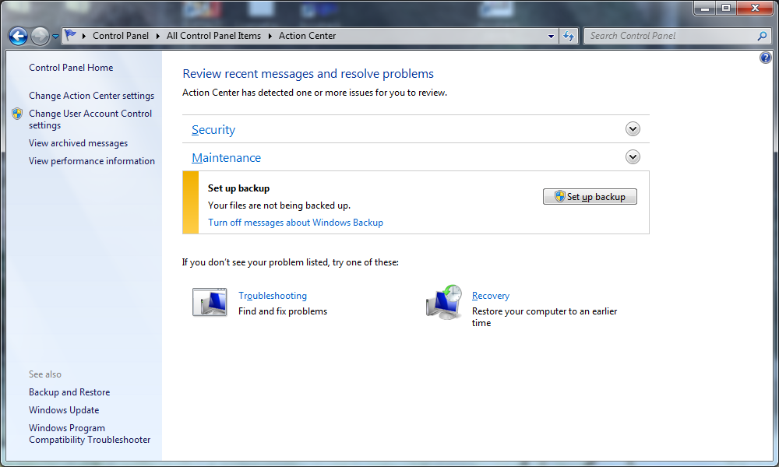

- Look for User Account Control and click on Change Settings.
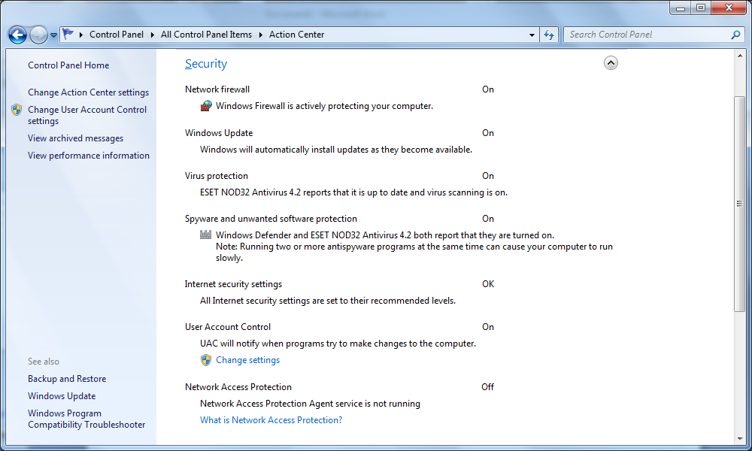

- Move the bar to the bottom “Never Notify” .

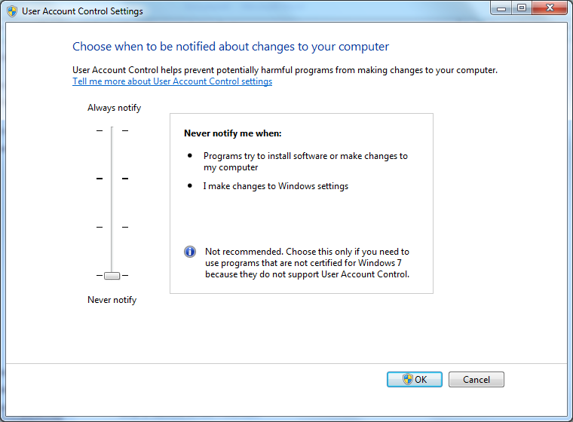

- Say Yes to the Confirmation message “Do you want to allow these changes”
You will receive the reboot message “You must reboot for changes to take effect”.
- Reboot computer.
How to Change Compatibility Settings
Accutrack has 2 executable files: Estimate.exe and AbcEng.exe. These files are typically installed into c:\Program Files (x86)\ABC Sign\ABC Estimate directory. Right-click the file and go to Properties. At the top of the screen in the tab area, click Compatibility.
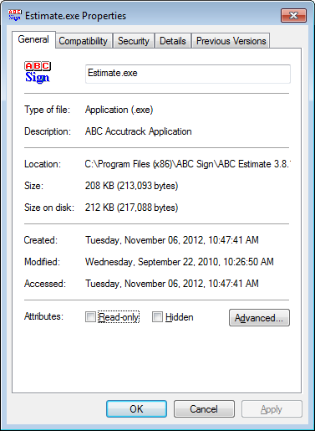

In Compatibility, check “Run this program in compatibility mode for Windows XP Service Pack 2 or 3”. In Windows 10 choose Windows 7 as your compatibility. Also check “Run this program as an administrator”.
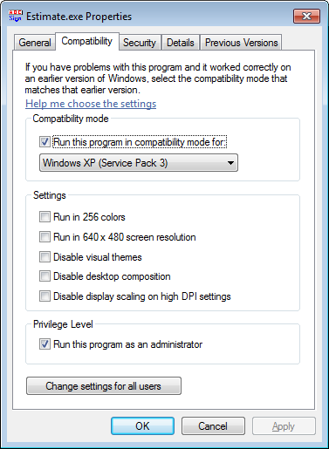

Change these settings for both Extimate.exe and AbcEng.exe. If you have any questions or problems, please contact Accutrack Support 1-888-530-2017.

